Fizz Design

Retro-Inspired Freelance Design Studio

Logo:

Tagline:

Helping Creatives Look as Bold as They Feel.

Mission:

Fizz Design blends nostalgic charm with bold visuals to help creatives show up loud, proud, and unapologetically original.

Color Palette:

1. Golden Brown

HEX: #926C22

RGB: (146, 108, 34)

2. Warm Medium Brown

HEX: #9C5C2C

RGB: (156, 92, 44)

3. Muted Coral

HEX: #D06E5F

RGB: (208, 110, 95)

4. Soft Terra Cotta

HEX: #DD8268

RGB: (221, 130, 104)

5. Light Peach

HEX: #F2BC9E

RGB: (242, 188, 158)

6. Pale Cream

HEX: #F7D7C8

RGB: (247, 215, 200)

Fonts :

**Creative & Artistic**

* **Headings:** Poppins Bold
* **Body:** Raleway or Source Sans Pro (stylish but readable)

/* Headings */

h1, h2, h3, h4, h5, h6 {

font-family: 'Poppins', sans-serif;

font-weight: 700; /* Bold */

}

/* Body text with Raleway */

body {

font-family: 'Raleway', sans-serif;

}

/* Or if you prefer Source Sans Pro for body instead */

body {

font-family: 'Source Sans Pro', sans-serif;

}

<link href="https://fonts.googleapis.com/css2?family=Poppins:wght@700&family=Raleway&family=Source+Sans+Pro&display=swap" rel="stylesheet">

Mood Board

Graphic Style:

- Abstract retro shapes (waves, squiggles, dots)

- Minimal layouts with punchy pops of color

- Vintage-inspired icons or badges

Imagery Vibe:

- Fun, bold, artsy

- Nostalgic but clean — like a creative twist on a 70s print ad

- Inspires movement, play, and confidence

Brand Voice:

- Friendly, empowering, expressive

- A little cheeky, always authentic

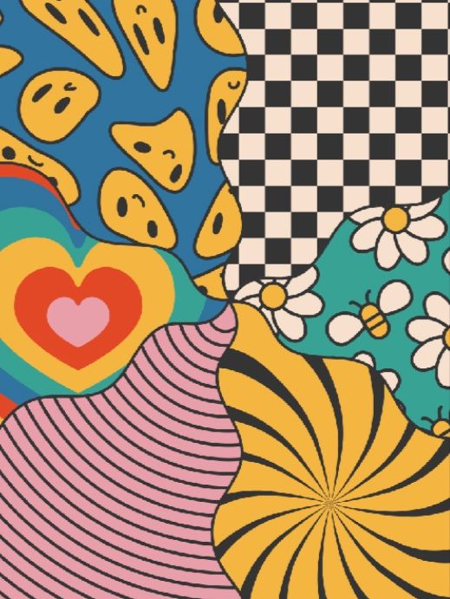

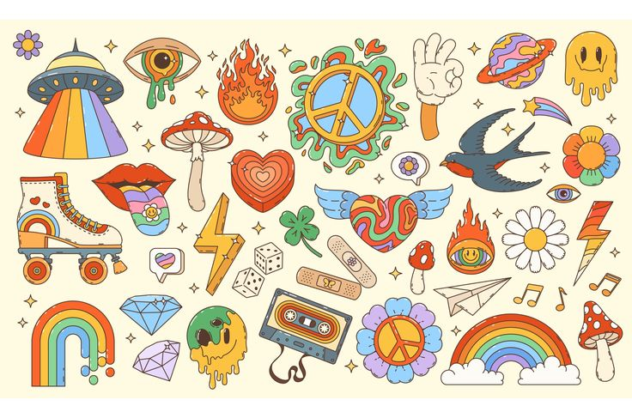

**Page 5: Social Media Templates (optional)**

You can include:

* Screenshots of your Canva templates
* Notes about layout consistency
* Font sizes, margins, etc.

**Fizz Design is officially LIVE!**  
Bringing bold, nostalgic, and unapologetically original design vibes to creatives everywhere. Ready to make your brand pop? Let’s create something unforgettable together!

• **New Service or Offering:**  
*Example:*  
✨ **Now Offering Custom Branding Packages!**  
From logos to full brand kits — tailored to your unique style. Let’s make your brand stand out with bold and friendly designs that capture your story.

• **Limited-Time Offer or Discount:**  
*Example:*  
🔥 **Summer Special: 15% off all logo designs!**  
Bold, edgy, and friendly branding — now at a hotter price. DM for details or visit our website to book your spot!

• **Portfolio or Project Reveal:**  
*Example:*  
🎨 **New Project Spotlight: Retro Revival Campaign**  
Check out our latest work inspired by vintage vibes and bold graphics. Ready to elevate your brand? Let’s chat!

• **Event or Webinar Invitation:**  
*Example:*  
🚀 **Join Our Free Webinar: Design That Pops**  
Learn how to create bold, memorable brands that get noticed. Spots are limited — reserve yours today!

Social bios

**Fizz Design**  
Bringing nostalgic charm and bold visuals to creatives who want to show up loud, proud, and unapologetically original.  
✨ Custom branding | Logo design | Visual storytelling  
Let’s make your brand pop! 🎨👇

[Your website or contact link]

Bold, nostalgic branding for creatives who dare to be original. Custom logos & visual magic.  
Let’s make your brand pop! 🎨✨